AI-Based Resume Screening and AI-Assisted Interview Evaluation Framework with Proctoring System
Jeet Mehta  [AUTHOR INPUT REQUIRED: department, institution, city, country]  [AUTHOR INPUT REQUIRED: e-mail address] | Pruthvi Mehta  [AUTHOR INPUT REQUIRED: department, institution, city, country]  [AUTHOR INPUT REQUIRED: e-mail address] | Vedant Korade  [AUTHOR INPUT REQUIRED: department, institution, city, country]  [AUTHOR INPUT REQUIRED: e-mail address] | Prof. Mrunali Desai  [AUTHOR INPUT REQUIRED: department, institution, city, country]  [AUTHOR INPUT REQUIRED: e-mail address]

Abstract—Automated resume screening ranks candidates on self-reported documents and cannot revise that judgment when later evidence contradicts it. This paper investigates whether an adaptive artificial intelligence (AI) interview stage can correct the ranking errors introduced by resume-only screening, and what candidate data such a pipeline exposes. We present a locally deployable pipeline that combines a deterministic applicant tracking system (ATS) keyword pre-filter, large language model (LLM) resume scoring, an adaptive interview, proctoring-based integrity scoring, and trust-weighted score fusion. A controlled audit on a 100-candidate synthetic cohort with concealed competence values, planted over-sellers and hidden gems, and two honest control groups shows that four resume-only rankers admitted six or seven over-sellers into the top ten. Fusing the interview stage raised NDCG@10 from 0.61 to 0.94 and Kendall's τ-b from 0.17 to 0.55 on the shipped draw; across 200 cohort regenerations the mean τ-b gain was 0.38 (95% interval 0.33–0.44) and the mean NDCG@10 gain was 0.29 (0.13–0.45), positive in every regeneration. The control displacement rate was 0.62, an upper bound rather than an error rate: 93.71% of honest control pairs kept their relative order. Transport-level interception showed candidate answers in 12 of 14 model calls against two for resume text. All ranking results are simulated and test the fusion function, not the interviewer; interviewer validity, fairness, and encryption at rest were not measured.
Index Terms—Automated hiring, resume screening, large language models, adaptive interviewing, score fusion, data privacy, algorithmic auditing.

I. Introduction
Large employers rely on automated screening to reduce a large applicant pool to a shortlist that humans can read. Applicant tracking systems (ATS) traditionally do this by matching keywords or predefined criteria against resume text [1]. Later systems adopted word embeddings with stable matching [2] and context-aware transformers for resume–job matching [3]; more recently, large language model (LLM) agents grade resumes at scale [4], and multi-agent designs add explanations to the scores [5]. Because hiring affects livelihoods, the correctness, robustness, and data handling of these systems matter.
Yet resume screening and interview assessment are still treated as separate filters: a resume score is computed once, gates later stages, and cannot be revised by subsequent evidence. A resume is self-reported, so one that overstates competence and one that understates it will each be ranked wrongly, and a screener that reads only that document cannot detect either error. Reported evaluations cover single components: Li et al. report 73.3% competence-level and 79.2% resume–job matching accuracy with an inter-annotator kappa of 61% [3], and Gan et al. report screening about elevenfold faster than manual review with an F1 of 87.7% [4]; neither examines whether a later stage corrects an earlier one. Fabris et al. describe whether algorithmic hiring is less biased than human alternatives as an open question [6], and Baxi et al. show that prompt-injection text in a resume can raise an LLM-assigned ranking under some conditions [7], a finding about screening alone.
We investigate whether an adaptive AI interview stage can correct ranking errors introduced by resume-only screening, and what data exposure such a pipeline entails. The contributions are: (i) a locally deployable pipeline with a deterministic keyword pre-filter, LLM resume scoring, an adaptive interview, proctoring-based integrity scoring, and trust-weighted fusion that lets an untrusted interview stop helping a candidate without penalizing them; (ii) a controlled audit on a synthetic cohort with concealed competence, planted over-sellers and hidden gems, and two honest control groups; (iii) a comparison of four resume-only rankers; (iv) transport-level measurement of data egress for hosted and local providers; and (v) a harness that labels every reported quantity by provenance and lists what could not be measured.
Over-sellers occupied six or seven of the top ten positions under all four resume-only rankers. Fusion raised NDCG@10 from 0.61 to 0.94 and Kendall's τ-b from 0.17 to 0.55 on the shipped draw, and every planted hidden gem moved up. The cost is reported equally: a control displacement rate of 0.62, an upper bound, since 93.71% of honest control pairs kept their order. Candidate answers appeared in 12 of 14 model calls against two for resume text. The cohort's resume inflation and unbiased-but-noisy interview are assumptions of the generator, so all ranking results are simulated and test the fusion function, not the interviewer; recruiters retain responsibility for every hiring decision. Section II reviews related work, III–V present the system, methodology, and formulation, VI the setup, VII the results, VIII limitations, and IX conclusions.

II. Related Work
Early ATS treated screening as deterministic document scoring [1]: fast and reproducible, but blind to differently worded descriptions of one competency and measuring the presence of terms rather than substantiated competence. Embedding-based work followed: Pudasaini et al. combined word embeddings with Gale–Shapley matching over both sides' preferences [2]; Vanetik and Kogan combined sentence embeddings, keywords, and named entities for vacancy ranking [8]; and Li et al. conditioned representations on resume sections and the paired job description, evaluating on 6,492 annotated resumes for one occupation [3]. Embedding similarity measures relatedness, not ability, and these methods still read self-reported content.
LLM-based systems replace fixed similarity with generative evaluation. Gan et al. summarize and grade resumes with LLM agents [4]. Lo et al. split screening across four agents and ground the evaluator in retrieved role criteria; on 105 anonymized resumes rated by human-resources professionals they report higher correlation with human scores and lower error than single-LLM baselines, and list video-interview analysis as future work [5]. Vaishampayan et al. compare human ratings with LLM matching scores [9]. Fairness and robustness are studied separately: Fabris et al. survey bias across the hiring pipeline [6], Iso et al. study gender, race, and education effects on LLM matching [10], FAIRE benchmarks identity-related changes in resume evaluation [11], and Baxi et al. show that injected self-promotion can raise, and in heterogeneous settings occasionally invert, LLM-assigned rankings [7], so resumes are an attack surface as well as an unreliable signal.
In these studies, one component is examined in isolation, the model's input is primarily the resume, none tests whether later interview evidence can revise the ranking, and none measures data egress. Automated and video interviewing, resume-conditioned question generation, remote proctoring, LLM-as-judge validity, and the ranking measures used here (NDCG, Kendall's τ-b, BM25, TF-IDF) are outside the source set of this paper. [LITERATURE REQUIRED: add and cite related work on automated/video interviewing, LLM interview assessment, remote proctoring, LLM-as-judge validity and human agreement, and the original references for NDCG, Kendall's tau-b, BM25 and TF-IDF.] No comparison with prior interview-assessment or proctoring systems is therefore claimed, and fairness literature [6], [10], [11] is context, not evidence that this system is fair.

III. System Architecture and Proposed Framework
The pipeline has five stages: keyword pre-filter (preceded by ingestion and sanitization), model screening, adaptive interview, integrity scoring, and trust-weighted fusion into a ranked report. Decisions are made in a service layer independent of the interface, so the web application and the measurement harness run the same code. Pages render, services decide, core modules hold pure scoring code, and a provider layer is the only path by which data can reach a model (Fig. 1). State is in SQLite (11 tables, write-ahead logging, enforced cascading foreign keys). After ingestion a candidate can be removed automatically at only one point, the keyword pre-filter; a low model score routes to human review.

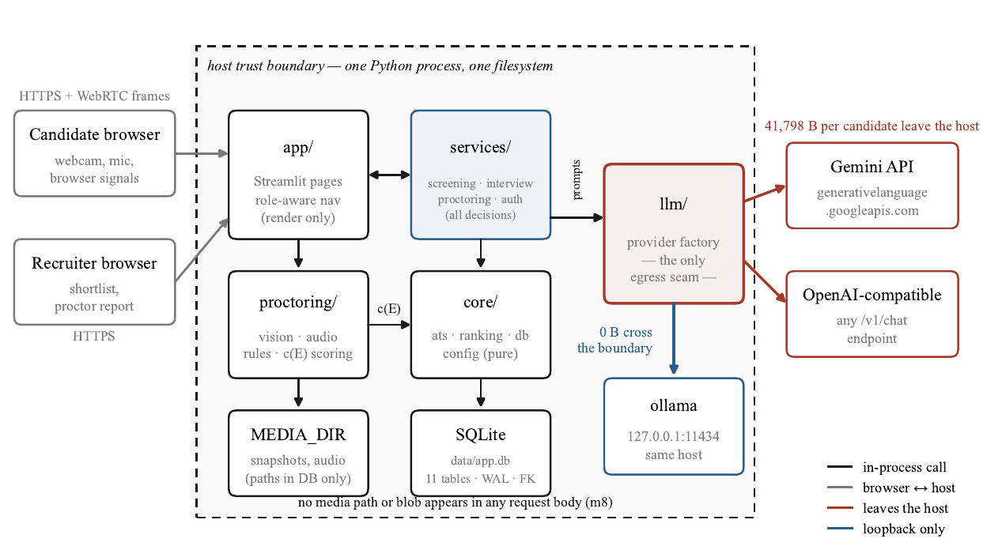
Fig. 1. System architecture and host trust boundary. Everything inside the dashed region runs in one process on the operator's machine; the provider factory is the one place any of it can reach the network. Under the hosted provider 41,798 B per candidate leave the host; under the local provider the same calls end at a loopback address.

Four design decisions shape the system. Provider abstraction: a hosted Gemini API, a local Ollama daemon, an OpenAI-compatible endpoint, and an offline fake are selected by configuration, with identical prompts. Deterministic first: sanitization, keyword scoring, integrity scoring, fusion, and ranking make no model call, so a throttled provider can delay a decision but not lose a submission. Recomputed totals: the model returns five criterion scores, and totals are recomputed from the clamped criteria. Prompts in files: four of the five templates in the released tree are loaded by the shipped pipeline; the fifth, evaluation_prompt.txt, is reachable only from an unused legacy module.
The system is written in Python 3.12 using PyMuPDF [12] and python-docx for extraction, Streamlit 1.63 [13] for the interface, and faster-whisper, a reimplementation of Whisper [14], for local speech recognition [CITATION REQUIRED: faster-whisper]. Vision uses OpenCV (YuNet [CITATION REQUIRED: YuNet], SFace [CITATION REQUIRED: SFace]) and MediaPipe [CITATION REQUIRED: MediaPipe]; optional object detection uses YOLO11n via ultralytics [CITATION REQUIRED: YOLO11n/ultralytics], which is AGPL-3.0 and disabled by default. Passwords use scrypt [CITATION REQUIRED: scrypt]. There are 17 pinned open-source dependencies, model calls use plain REST, recorded media stays on local disk, and the 404-case test suite runs offline. Table I summarizes the modules.
Table I
Modules, inputs, outputs, and techniques
Module | Input | Output | Technique | Model calls
Sanitizer | resume text | cleaned text, flags | 5 regex families | none
Pre-filter | text, requirements | S_{ats}, missing list | literal word-boundary match | none
Screening | text, role | S_{resume} (0–25) | 5-criterion rubric, schema-constrained | 1
Interview | plan, answers | transcript, S_{interview} | bounded turn policy, 2-tier guardrail | plan, turns, tier 2, score
Integrity | events | c(E), verdict | per-kind worst severity, log persistence | none
Fusion | three scores | S_{final}, rank | trust-weighted convex mix | none

IV. Methodology

A. Stages 1–2: Pre-Filter and Screening
Text is extracted (PDF, DOCX, or plain), normalized, and refused if under 40 words. No structured field extraction is performed; the cleaned text is passed to the model truncated at 18,000 characters, avoiding a parser as a second error source. Sanitization removes instruction-like text using five regex families (instruction override, persona hijack, chat markup, score demand, verdict demand), never rejects a resume, and records a flag so a recruiter sees what changed, since a pattern match cannot tell an attack from a security engineer describing their work.
The pre-filter score S_{ats} (Eq. (1)) is the share of a role's requirements found literally in the resume. A resume with S_{ats} < τ_{ats} = 40 is rejected without a model call and the reason names the missing requirements, so every automatic rejection is explainable as a list of terms. A role with no requirements returns 0, so 0 < τ_{ats} rejects every applicant; requirements must be populated before a role is published. Surviving resumes receive one schema-constrained model call scoring skill match, experience, projects, communication, and culture fit from 0 to 5 (Eq. (2)); the prompt marks the resume as untrusted and lists unmatched requirements so genuine equivalents can be credited. A candidate with S_{resume} ≥ s_{min} = 15 is shortlisted; otherwise the candidate goes to human review, never to automatic rejection.

B. Stage 3: Adaptive Interview
A plan of at most 12 questions is generated from the resume and job description, each tagged resume, job-description gap, culture, or behavioral. Unevidenced requirements become gap questions, so the interview probes claims the document does not substantiate. Two design properties limit its contribution: the plan is conditioned on the same resume and pre-filter gaps, and the same provider screens and interviews, so the interview is an additional, not independent, evidence source (Section VIII).
After each answer a turn policy chooses probe, steer, next planned, or wrap up. Bounds are enforced before the model is consulted (turn budget, wall clock, unasked plan, at most two consecutive adaptive turns); the model cannot end the interview while planned questions remain, and planned questions are asked verbatim. A steer is triggered by keyword match against watch topics, needing no model call. A two-tier guardrail checks each answer: tier 1 is structural and pattern-based; tier 2, a model check, runs only when word overlap with the question is below 0.06 and fails open with a flag. A rejected answer does not spend the turn, and after three rejections it is accepted with a forced-accept flag. One call scores technical depth, problem solving, communication, culture fit, and practical impact from 0 to 5 (Eq. (3)).

C. Stages 4–5: Integrity and Fusion
Proctoring runs in-process using vision, audio loudness, and browser signals, producing events of 13 kinds and four severities (weights 12, 6, 3, 1). The integrity score c(E) (Eqs. (4)–(5)) charges each distinct kind its worst severity times a logarithmic persistence term, scaled by a capped co-occurrence factor. The verdict is flag below 55, clean at 80 or above with no critical event, and review otherwise; a single critical event, scoring 88 arithmetically, is held at review. The function is deterministic and order-independent and is evidence for a human, not a finding of misconduct.
Integrity neither gates nor multiplies the final score; it sets how much weight the interview receives (Eqs. (6)–(9)). As t → 0 the fused score collapses onto S_{resume}, not zero: an untrusted interview cannot numerically penalize a candidate. This is a statement about scores, not positions. Ordering uses Eq. (10); the final key makes it total, needed because the rubric has only 26 values and 97 of 100 cohort candidates share a screening score.

V. Mathematical Formulation and Algorithms
Let R be the resume, J the role's requirement list, and M ⊆ J the requirements found literally in R. clamp(x, a, b) = min(max(x, a), b) and round(x) rounds to the nearest integer. S_{ats} and c(E) lie in [0, 100]; S_{resume} and S_{interview} are integers in [0, 25]. Fusion mixes only the two 0–25 scores, with c(E)/100 as a dimensionless weight.
$S_{ats} = round(100 · |M| / |J|)$ if $|J| ≥ 1$,
$S_{ats} = 0$ if $|J| = 0$ (1)
$S_{resume} = Σ_{i=1}⁵ clamp(a_{i}, 0, 5)$ (2)
$S_{interview} = Σ_{j=1}⁵ clamp(b_{j}, 0, 5)$ (3)
where a_{i} and b_{j} are the model's raw criterion scores; any model-reported total is discarded. With K the distinct event kinds, E_{k} the events of kind k, s_{k} the worst severity of kind k, and w(s) its weight,
$d = ( Σ_{k∈K} w(s_{k}) (1 + γ ln|E_{k}|) )$
$· min(κ, 1 + σ(|K| − 1))$ (4)
$c(E) = clamp(round(100 − d), 0, 100)$ (5)
with γ = 1, σ = 0.25, κ = 2. With trust t = c(E)/100 and interview weight λ ∈ [0, 1] (default 0.5),
$t = c(E) / 100$ (6)
$v = t S_{interview} + (1 − t) S_{resume}$ (7)
$S_{final} = (1 − λ) S_{resume} + λ v$ (8)
$S_{final} = S_{resume} + λ t (S_{interview} − S_{resume})$ (9)
$(−S_{final}, −S_{resume}, −S_{ats}, application id)$ (10)
Eq. (9) follows from (7) and (8): the effective interview weight is λ t. Eq. (10) is the ascending lexicographic ordering key. Algorithm 1 combines the stages.
Algorithm 1. End-to-end candidate evaluation
Input: resume file F, role J, thresholds τ_{ats}, s_{min}, weight λ. Output: outcome; S_{final} if interviewed.
1: R ← normalize(extract(F)); if |words(R)| < 40 return REFUSED
2: R′ ← sanitize(R) ▷ strip and flag; never reject
3: S_{ats} ← keyword_score(R′, J); if S_{ats} < τ_{ats} return REJECTED
4: S_{resume} ← Eq. (2); if S_{resume} < s_{min} return UNDER REVIEW
5: plan ← build_plan(R′, J); E ← ∅; transcript ← ∅
6: while turn budget and clock allow do
7: q ← next_turn(plan, transcript); if q = WRAP UP break
8: a ← accept_answer(q) ▷ ≤ 3 rejections, then force
9: transcript ← transcript ∪ {(q, a)}; E ← E ∪ proctor_events()
10: S_{interview} ← Eq. (3); c(E) ← Eqs. (4)–(5)
11: return S_{final} from Eqs. (6)–(8), ordered by Eq. (10)

VI. Experimental Setup and Evaluation Metrics
Environment. Measurements were taken on Python 3.12.10, Windows 11, AMD64, Intel64 Family 6 Model 158 Stepping 10, CPU-only [AUTHOR INPUT REQUIRED: commercial CPU model name and installed RAM], with the offline fake provider, a throwaway database, and proctoring disabled. The artefact inventory was regenerated on 2026-10-11 at commit 0b93173 [VERIFICATION REQUIRED: choose one commit hash to cite for all results (the original run used 11b9495), state the date of the latency run, and re-read every table value, latency figure, and artefact count from the regenerated results.json before submission]. Two classes were not offline: live provider-contract probes against gemini-2.5-flash, and loopback egress measurements with stubbed responses and no local-model inference. The harness (python -m metrics.run_all) is released at [AUTHOR INPUT REQUIRED: repository URL]. Every quantity carries a harness-assigned label: measured, derived, specification, simulated, or unavailable (never given a value). The regenerated set comprises 243 quantities: 131 measured, 24 derived, 37 simulated, 35 specification, 16 unavailable.
Synthetic cohort. Each candidate has a latent competence θ, drawn uniformly within a per-case band ([0.05, 0.40] for over-sellers and honest-weak; [0.60, 0.95] for hidden gems and honest-strong), with 25 candidates per case (100 total) and seed 20260923. No ranker sees θ. The views are
$ρ = clamp(θ + β_{case} + ε_{r}, 0, 1)$, $ε_{r} ~ N(0, 0.08²)$ (11)
$ι = clamp(θ + ε_{i}, 0, 1)$, $ε_{i} ~ N(0, 0.08²)$ (12)
$S_{ats} = round(clamp(100ρ + ε_{a}, 0, 100))$, $ε_{a} ~ N(0, 6²)$ (13)
with β_{case} = +0.55 (over-seller), −0.45 (hidden gem), 0 (honest). Screening and interview scores are round(25ρ) and round(25ι). The interview is thus unbiased but noisy, the most consequential assumption in the paper and an assumption of the generator, not a finding. The keyword score follows resume claims, so over-sellers pass the lexical gate. Integrity is fixed at 100, so the headline audit is at full trust; degraded trust is a separate sensitivity sweep.
Baselines. TF-IDF uses log term frequency, smoothed idf log(1 + N/df), and L2-normalized cosine; BM25 is Okapi with k₁ = 1.5, b = 0.75 over the same idf (smoothing avoids negative idf for common terms). The query is the role title, description, and requirements. The keyword baseline is Eq. (1). The fourth ranker, the simulated model score, reads the cohort's concealed resume view and is not a real model run; it is labelled simulated throughout, and a real zero-shot baseline and a sentence-embedding baseline have not been run. All rankers use one five-requirement role, the Junior Data Engineer role (Python, SQL, ETL, Pandas, AWS basics); two catalogue roles tie at five requirements, so the role is named explicitly. Table II breaks ties by candidate id, whereas the fusion audit's resume-only ranking breaks them on the keyword score. The simulated ranker therefore scores NDCG@10 0.5572 under the arbitrary tie-break and 0.6087 under the informative one: the 0–25 rubric yields only 24 distinct scores on this cohort, 97 of 100 candidates share a score (largest tie group 10), and the two keys order 83 of 100 positions differently, so the tie-break accounts for the whole difference.
Metrics. The relevant set is the top quartile by concealed competence (25 candidates). NDCG@10 uses competence as graded relevance; τ-b tolerates the ties of a 0–25 rubric. Rank shift is ΔR = rank_{after} − rank_{before} (negative is improvement). Recovery is the share of a planted case moving in the implied direction. The control displacement rate is the share of honest controls moving more than five positions (5% of the cohort). Direction is tested with an exact two-sided sign test; uncertainty uses 95% bootstrap intervals within the cohort and 95% intervals over 200 regenerated cohorts. Precision@10 and MRR are not reported as point estimates because their across-regeneration intervals are too wide (widths 0.40, 0.40, 0.86, 0.67 [VERIFICATION REQUIRED: map these widths to precision and MRR, resume-only and fused]).
Corpora and procedures. The guardrail corpus (31 attacks over five families; 18 benign strings, 10 hard negatives such as a security engineer describing injection work) and the boundary corpus (26 resume-fragment/requirement cases, three probing synonyms, abbreviations, and concepts, scored 23 and 26 ways) were hand-written by the authors. Egress was measured by replacing the HTTP session with an interceptor that records every request body for full candidate journeys under three providers, with two resume sizes for slope and overhead, and scanning all bodies for media paths, extensions, data URIs, and base64. Latency used a stubbed provider, three warm-ups, 40 repetitions (fewer for PDF extraction, scrypt, registration, and service stages), and p50/p95.

VII. Results and Discussion

A. Resume-Only Rankers and Fusion
BM25 reached the highest NDCG@10 among resume-only rankers (0.6234), then TF-IDF (0.5846), the simulated model score (0.5572), and keyword (0.4843); over-sellers occupied seven of the top ten under keyword and TF-IDF and six under BM25 and the simulated score (Table II). The fused ranking reached 0.9440.
Table II
Resume-only rankers on the simulated cohort (simulated)
Ranker | NDCG@10 | Kendall τ-b | Over-sellers in top 10
Keyword (ATS) | 0.4843 | 0.1240 | 7
TF-IDF (cosine) | 0.5846 | 0.1026 | 7
BM25 | 0.6234 | 0.0949 | 6
Simulated model score | 0.5572 | 0.1681 | 6
Fused (reference) | 0.9440 | 0.5471 | —

On the shipped draw, fusion raised NDCG@10 from 0.6087 to 0.9440 and τ-b from 0.1701 to 0.5471. All 25 hidden gems moved up and all 25 over-sellers moved down (recovery 1.00 over 50 planted errors), a mean gain of 21.4 and loss of 24.48 positions (Table III, Fig. 2).
Table III
Per-case rank movement under fusion (simulated)
Case | n | Mean ΔR (places) | 95% bootstrap CI | Outcome | Sign-test p
Over-seller | 25 | +24.48 | [+21.48, +27.52] | 25/25 moved down | 5.96e-08
Hidden gem | 25 | −21.40 | [−24.52, −18.24] | 25/25 moved up | 5.96e-08
Honest strong | 25 | −10.60 | [−13.68, −7.64] | 9/25 within tolerance | 5.96e-08 (upward)
Honest weak | 25 | +7.52 | [+4.60, +10.48] | 10/25 within tolerance | 9.11e-04 (downward)

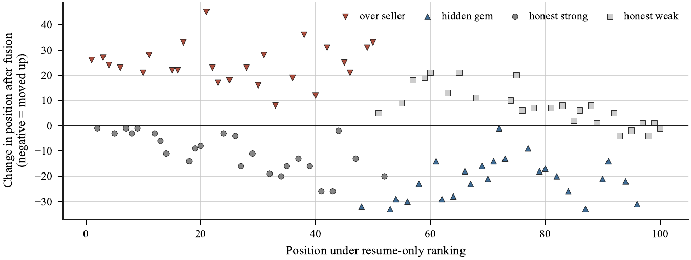
Fig. 2. Per-candidate rank change under fusion against the resume-only position, shipped draw. Over-sellers fall and hidden gems rise; the spread of honest controls is the cost of the correction. Simulated cohort: this tests the fusion function, not the interviewer.

Of 50 honest controls, 31 moved more than five positions (displacement rate 0.62): 16 honest-strong moved up (mean 15.25 places) and 15 honest-weak moved down (mean 12.27). This is an upper bound on cost, not an error rate, since half the cohort is deliberately mis-scored and controls must move to let corrected candidates pass. The controls' own ordering became more faithful to competence (τ-b 0.7861 to 0.8596), and 1,148 of 1,225 control pairs (0.9371) kept their order, leaving 77 pairs (0.0629) inverted, the defensible cost figure.
Over 200 regenerated cohorts the mean fused τ-b was 0.5812 [0.5308, 0.6315], the mean τ-b gain 0.3826 [0.3333, 0.4388], and the mean NDCG@10 gain 0.2855 [0.1257, 0.4514]; both gains were positive in 200 of 200 draws and all shipped-draw quantities fall inside their intervals (Table IV). The λ sweep (Fig. 3) gave τ-b 0.7903 at λ = 0.95 versus 0.5471 at the shipped 0.5; across regenerations the maximizer took five grid values, 0.95 in 132 of 200 draws, never below 0.8. The shipped 0.5 was fixed before the sweep and is not retuned; the sweep is a sensitivity analysis with no recommended value.
Table IV
Across-seed intervals over 200 regenerations (simulated)
Quantity | Shipped draw | Mean | 95% interval | Range
τ-b, resume-only | 0.1701 | 0.1986 | [0.1268, 0.2744] | [0.0796, 0.2921]
τ-b, fused | 0.5471 | 0.5812 | [0.5308, 0.6315] | [0.5075, 0.6469]
τ-b gain | 0.3770 | 0.3826 | [0.3333, 0.4388] | [0.3156, 0.4501]
NDCG@10, resume-only | 0.6087 | 0.6699 | [0.5008, 0.8357] | [0.4222, 0.8882]
NDCG@10, fused | 0.9440 | 0.9553 | [0.9207, 0.9800] | [0.9029, 0.9852]
NDCG@10 gain | 0.3353 | 0.2855 | [0.1257, 0.4514] | [0.0672, 0.4916]

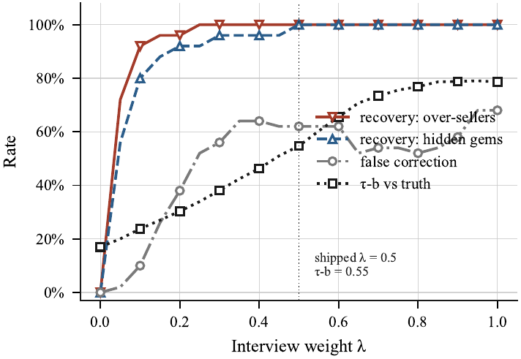
Fig. 3. Sensitivity to interview weight λ (steps of 0.05, shipped draw). Recovery and control displacement both rise with λ. λ was fixed at 0.5 before the sweep; no value is recommended.

B. Integrity, Guardrail, and Pre-Filter
An event-free session scored 100/clean; a single critical event 88/review; six repeated no-face events 83/clean and forty 72/review; a phone, notes, background voice, and two glances (five events, four kinds) 75/review; one glance 97; three glances and a blur 88; a second person twice 90; four tab switches and two pastes 76/review. The score was non-increasing over 39 cumulative additions, identical over 1,000 calls, and order-independent. With integrity 0 for the whole cohort, every fused score equalled its resume-only score exactly and the orderings coincided; across 2,100 candidate–integrity pairs the fused score never left the interval between the resume-only and fully trusted scores. Sweeping integrity applied to the whole cohort gave τ-b 0.1701, 0.2521, 0.3382, 0.3636, 0.4428, 0.5099, and 0.5471 at integrity 0, 25, 50, 55, 75, 90, and 100, with over-seller recovery 0.00, 0.92, and 1.00 from 50 upward.
The tier-1 guardrail flagged 28 of 31 attacks (detection 0.9032): 7/9 instruction override, 4/5 persona hijack, and 7/7, 5/5, 5/5 for chat markup, score demand, and verdict demand. The three evasions were a leetspeak variant, a hyphenated variant, and a polite paraphrase with no imperative verb. Four benign strings, all hard negatives, were flagged: false-positive rate 0.2222 overall and 0.40 on hard negatives; precision 0.875, recall 0.9032, F1 0.8889, specificity 0.7778, accuracy 0.8571; tier-2 escalation on benign input 0.7778. Sanitization never rejected a hostile resume; all 28 rewritten resumes carried flags and none was flagged without being rewritten. The false-positive rate is the cost of that design: two in five hard negatives were stripped, which is why the resume path flags and defers to a human.
On the 26 boundary cases the pre-filter matched the label in 24 (accuracy 0.9231; 11 TP, 1 FP, 1 FN, 13 TN), and in 21 of 23 decidable cases (0.9130). The three semantic cases were correctly no-match, measuring the price of no synonym expansion. One disagreement is a labelling question: "C++ only, no plain C work" against "C" returned a match, but the fragment contains a standalone "C" in "plain C work", so a literal match is defensible and the hand label, which ignores the negation, is the weaker party. The other is also a labelling error: "Expert in PostgreSQL" against "SQL" was labelled a match but correctly returned no match (relabelling that case gives 22 of 23, and relabelling both gives 23 of 23). A five-requirement role admits six scores, so τ = 40 means at least two matches.

C. Latency, Egress, and Provider Contract
With the provider stubbed, scoring stages ran below 0.5 ms at p50; scrypt (119.35 ms), registration (120.92 ms), and PDF extraction (51.03 ms) dominated (Table V). These are single-machine CPU-only figures excluding model inference. Four deterministic functions returned identical output on all 50 calls; salted hashing is excluded from that claim.
Table V
Offline stage latency (ms), provider stubbed
Stage | n | p50 | p95
PDF text extraction (9 pages) | 10 | 51.03 | 51.34
Sanitization (hostile input) | 40 | 0.106 | 0.108
Keyword score (5 requirements) | 40 | 0.097 | 0.148
Integrity score, 200 events | 40 | 0.0676 | 0.0680
Rank 100 candidates | 40 | 0.373 | 0.513
Scrypt hash / verify | 8 | 119.35 / 119.31 | 120.87 / 120.97
Register candidate | 6 | 120.92 | 122.95
Screen (provider stubbed) | 15 | 0.506 | 0.730

In one 14-call journey with a 546-byte generated resume, the hosted provider issued 14 requests carrying 41,798 bytes to one external host, and the local provider 14 requests carrying 40,870 bytes to a loopback address, so none crossed the network (ratio 0.9778; Fig. 4). Resume text appeared in 2 of 14 calls and candidate answers in 12 of 14. The two-point comparison (546 and 5,469 bytes) gives a slope of 2.0 request bytes per resume byte and a fixed overhead of 39,778 bytes. All 57 intercepted bodies contained no media path, extension, data URI, or base64 blob. Six of the 14 calls were tier-2 calls, a property of the stub rather than a rate. Seven of 14 calls were schema-constrained, consistent with two of five call sites being so constrained.
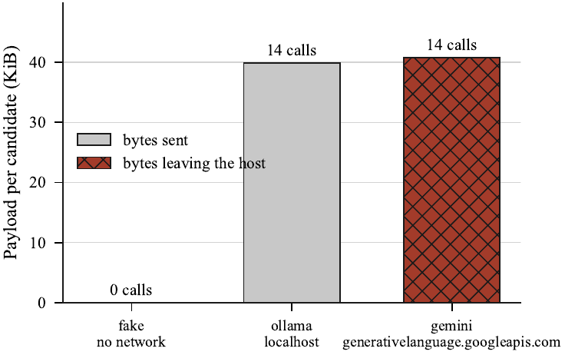
Fig. 4. Request payload per candidate, measured by intercepting the real provider code. Volume is the same for local and hosted configurations; the recipient differs. Biometric media leaves the host under neither.
Two schemas using 11 allowed keywords were sent to the hosted provider; sanitization preserved all required fields. In a live run against gemini-2.5-flash [AUTHOR INPUT REQUIRED: date of the live provider-contract run], both shipped schemas were accepted, and both the pre-fix and an unsanitized schema were rejected with HTTP 400. Mean round trip was 4.146 s (5.309 s, 2.983 s); the two probes billed 603 reasoning tokens against 324 visible tokens (two observations, not a constant). The regenerated inventory has 34 source files (10,911 lines) and 18 test files with 385 test functions and 404 collected cases, the same as pytest's own collection (test-to-source code-line ratio 0.457); the database has 11 tables, 121 columns, 7 foreign keys with 7 cascades, 22 personal-data and 4 biometric-media columns.

D. Discussion
No resume-only method kept over-sellers out of the shortlist: four methods, lexical and model-shaped alike, admitted six or seven into ten slots, and BM25 outscored the simulated model screener. The results do not show that the pipeline screens better; they show that the shortlist held the wrong candidates however it was ranked, and that a second evidence source reorganized it, with a positive gain in all 200 regenerations. The 0.62 displacement is mostly bookkeeping for corrections, with 6.29% of control pairs inverted as the cost. The 0–25 rubric cannot separate 100 candidates, so whatever breaks its ties does the ranking, which is why the resume-only baseline varies with the tie-break (Section VI). The egress result concerns destination, not size: one configuration value decides whether the same payload crosses the network, and because answers appear in 12 of 14 calls against two for resumes, a privacy analysis of the resume alone examines the wrong surface.

VIII. Limitations and Threats to Validity
Circularity. Resume inflation and an unbiased-but-noisy interview are generator assumptions; results test the fusion function, not whether an interviewer supplies evidence of that quality, and all rates are conditional on noise 0.08. A real interviewer persuaded by a confident over-seller would reproduce the error fusion aims to correct. Non-independence. The interview plan derives from the same resume and the same model family screens and interviews, so self-preference cannot be excluded and no human rater exists to test it; the interviewer cannot be stated accurate. Realism and scale. Resumes are template-generated; there are 25 candidates per case and one five-requirement role, so generalization to other roles is untested. Self-authored corpora. The detection rate (0.9032) and boundary accuracy (0.9231) are regression figures against corpora written by the authors; no adaptive adversary was modelled, and no claim of security against prompt injection is made. Fixed integrity, stubs, and hardware. The headline audit is at integrity 100; egress and latency used stubbed responses on one CPU-only machine, and 12-of-14 describes one probe journey.
Ethics. The pipeline processes biometric data; the database holds 22 personal-data columns, 4 referencing biometric media, and consent is recorded first. Integrity output is advisory, the only automatic rejection is the keyword filter, and a human decides every disposition. Under the hosted provider, resume text and every answer reach a third-party processor, placing the deployment in the EU high-risk employment category [CITATION REQUIRED: GDPR processor provisions and the EU AI Act high-risk employment category]. Two gaps are material: no encryption at rest, so filesystem permissions are the only control, and deletion functions that nothing schedules, so retention is an operator action. No demographic attribute is collected or evaluated, so no fairness claim is made.

IX. Conclusion and Future Work
Resume-only screening cannot revise its judgment when later evidence contradicts it. We built a locally deployable pipeline in which the interview is an additional evidence source fused by trust weighting, so low-integrity evidence contributes less without lowering the resume score. On the simulated cohort, four resume-only rankers admitted six or seven over-sellers into the top ten; fusion raised NDCG@10 from 0.61 to 0.94 and τ-b from 0.17 to 0.55, positive in all 200 regenerations, at a displacement cost of 0.62 that is mostly consequential rather than a re-judgement. Candidate answers appeared in 12 of 14 model calls against two for resumes, and loopback routing reduced non-loopback egress from 41,798 bytes to zero. These results are simulated and do not establish interviewer validity.
Future work, each a precondition for stronger claims: (1) record interviews and score them with at least three human raters, reporting inter-rater agreement and model-to-human correlation; (2) run the ablation ladder with real zero-shot and embedding baselines on a local model; (3) report local inference latency, throughput, and memory with model, quantization, and hardware; (4) implement encryption at rest and scheduled retention; and (5) extend the generator to protected attributes for a disaggregated fairness study, and repeat on technical and non-technical roles and on real resumes under a documented licence.

Acknowledgment
[AUTHOR INPUT REQUIRED: acknowledgments and the AI-assistance disclosure statement required by the target venue]

References
[1] A. Tiwari, S. Vaghela, R. Nagar, and M. Desai, "Applicant tracking and scoring system," Int. Res. J. Eng. Technol. (IRJET), vol. 6, no. 4, pp. 320–324, Apr. 2019. [VERIFICATION REQUIRED: no independent record of this paper could be found; confirm volume, issue, pages, and authors from the publisher, or replace it, since it supports a load-bearing claim in Section I]
[2] S. Pudasaini, S. Shakya, S. Lamichhane, S. Adhikari, A. Tamang, and S. Adhikari, "Scoring of resume and job description using Word2vec and matching them using Gale–Shapley algorithm," in Expert Clouds and Applications, 2022, pp. 705–713, doi: 10.1007/978-981-16-2126-0_55. [VERIFICATION REQUIRED: the project's revision guide reports year 2021 and pages 691–699 for this DOI; the manuscript gives 2022 and 705–713. Confirm against the publisher record]
[3] C. Li, E. Fisher, R. Thomas, S. Pittard, V. Hertzberg, and J. D. Choi, "Competence-level prediction and resume & job description matching using context-aware transformer models," in Proc. 2020 Conf. Empirical Methods in Natural Language Processing (EMNLP), 2020, pp. 8456–8466, doi: 10.18653/v1/2020.emnlp-main.679.
[4] C. Gan, Q. Zhang, and T. Mori, "Application of LLM agents in recruitment: A novel framework for automated resume screening," J. Inf. Process., vol. 32, pp. 881–893, 2024, doi: 10.2197/ipsjjip.32.881.
[5] F. P.-W. Lo, J. Qiu, Z. Wang, H. Yu, Y. Chen, G. Zhang, and B. Lo, "AI hiring with LLMs: A context-aware and explainable multi-agent framework for resume screening," in Proc. IEEE/CVF Conf. Computer Vision and Pattern Recognition Workshops (CVPRW), 2025, [VERIFICATION REQUIRED: page range and DOI. Three page ranges appear in the project files (4184–4193; 4223–4232; 4193–4202 in the supplied PDF), and the DOI 10.1109/cvprw67362.2025.00402 appears only in the revision guide. Entry [5] was also missing from the reference list of the manuscript]
[6] A. Fabris, N. Baranowska, M. J. Dennis, D. Graus, P. Hacker, J. Saldivar, F. Zuiderveen Borgesius, and A. J. Biega, "Fairness and bias in algorithmic hiring: A multidisciplinary survey," ACM Trans. Intell. Syst. Technol., vol. 16, no. 1, art. 16, pp. 1–54, 2025, doi: 10.1145/3696457.
[7] P. Baxi, J. Xu, J. Y. Jiang, and S. Jasin, "Prompt injection in automated résumé screening with large language models: Single and multi-injection settings," in Findings of the Association for Computational Linguistics: ACL 2026, 2026, pp. 2942–2953, doi: 10.18653/v1/2026.findings-acl.142.
[8] N. Vanetik and G. Kogan, "Job vacancy ranking with sentence embeddings, keywords, and named entities," Information, vol. 14, no. 8, p. 468, 2023, doi: 10.3390/info14080468.
[9] S. Vaishampayan, H. Leary, Y. B. Alebachew, L. Hickman, B. Stevenor, W. Beck, and C. Brown, "Human and LLM-based resume matching: An observational study," in Findings of the Association for Computational Linguistics: NAACL 2025, 2025, pp. 4823–4838, doi: 10.18653/v1/2025.findings-naacl.270.
[10] H. Iso, P. Pezeshkpour, N. Bhutani, and E. Hruschka, "Evaluating bias in LLMs for job-resume matching: Gender, race, and education," in Proc. 2025 Conf. Nations of the Americas Chapter of the Association for Computational Linguistics: Human Language Technologies, Vol. 3: Industry Track, 2025, pp. 672–683, doi: 10.18653/v1/2025.naacl-industry.55.
[11] A. Wen, T. Patil, A. Saxena, Y. Fu, S. O'Brien, and K. Zhu, "FAIRE: Assessing racial and gender bias in AI-driven resume evaluations," arXiv:2504.01420, 2025.
[12] PyMuPDF, "PyMuPDF documentation," 2023. [Online]. Available: https://pymupdf.readthedocs.io/
[13] Streamlit Inc., "Streamlit documentation," 2023. [Online]. Available: https://docs.streamlit.io/
[14] A. Radford et al., "Whisper: Robust speech recognition via large-scale weak supervision," 2022. [AUTHOR INPUT REQUIRED: complete author list, arXiv identifier or venue, and DOI/URL]

